**About Me**

|  |  |
| --- | --- |
|  | Welcome to BILALGSM STORE We connect millions of buyers and sellers around the world, empowering people & creating economic opportunity for all.Within our markets, millions of people around the world connect, both online and offline, to make, sell and buy unique goods. We also offer a wide range of Seller Services and tools that help creative entrepreneurs start, manage and scale their businesses. Our mission is to re imagine commerce in ways that build a more fulfilling and lasting world, and we’re committed to using the power of business to strengthen communities and empower people. BILALGSM STORE is Registered & Authorized, Distributor in Pakistan/Worldwide. We Are Providing 100% Original Products That is Certified Company Best Quality Products. [Contact – BilalGsm](https://bilalgsm.com/contact/) |

**Integrated circuit (IC) for mobile devices and embedded multimedia card (eMMC) chip**

Mobile Phone Components:

Integrated Chip (IC) System-on-a-Chip (SoC), containing multiple chips in one package Application Processor (main computing unit) Graphics Processing Unit (GPU) for handling graphics Central Processing Unit (CPU) for executing commands Power Management IC (controls power distribution) Baseband Processor (handles cellular communication) Memory IC (stores data and applications) Flash Memory (non-volatile memory for long-term storage) RAM (volatile memory for short-term storage) NAND Flash/NOR Flash (types of flash memory) Modem IC (converts digital signals to analog signals for communication) Wireless Communication IC (handles cellular and Wi-Fi connections) RF Transceiver (sends and receives radio signals) Audio Codec IC (converts analog audio signals to digital) Video Codec IC (converts video signals to digital) Sensor IC (detects physical properties like motion or light) Camera ISP (Image Signal Processor) for enhancing camera images Touchscreen Controller (manages touchscreen input) * USB Controller (for connecting to other devices) Bluetooth/Wi-Fi IC (wireless connectivity) GPS Receiver IC (determines location) Security IC (e.g., Secure Element) for protecting sensitive data * Signal Processing IC (processes signals for various functions).

**CHARGING POWER IC**

A charging power IC is an essential part of devices that need to charge batteries. It controls how the battery is charged by adjusting the amount of electricity and voltage that goes to it. This helps the battery charge safely and efficiently. It also has features like protecting against overcharging and overheating to keep the battery and the device safe. Charging power ICs come in many different types and sizes to work with different kinds of batteries (like lithium-ion and nickel-metal hydride) and charging methods (like wired and wireless). They are very important in portable electronics today, because they make sure that devices can be charged safely and correctly. BELOW DIFFERENT CHARGING POWER IC MODELS SUPPOTS DIFFERENT MODLES OF ANDROID SMART PHONE LIKE SAMSUNG, APPLE IPHONE, IPAD, MACE BOOK, HUAWEI HONOR, OPPO, TECHNO INFINIX, REALME, REDMI, XIAOMI, MIZUE, ONE PLUS, ASUS,LG, GOOGLE, CHINA MTK ETC. AVAILABE AT [Contact – BilalGsm](https://bilalgsm.com/contact/)

**BACK LIGHT DISPLAY LIGHT AND COIL IC**

A BACK LIGHT DISPLAY LIGHT AND COIL IC (driver or LED driver IC) is used in devices with LCD screens. It controls the screen's backlight by providing the correct voltage and power to light it evenly at the desired brightness. Backlight and coil ICs are essential for LCD screens in smartphones, tablets, laptops, TVs, and monitors. They regulate power to the LED backlight system, ensuring proper performance and energy efficiency. These ICs often have features like dimming control, overvoltage protection, and temperature monitoring for reliability and safety. They come in different designs to meet specific device requirements. BELOW DIFFERENT BACK LIGHT DISPLAY LIGHT AND COIL IC MODELS SUPPOTS DIFFERENT MODLES OF ANDROID SMART PHONE LIKE SAMSUNG, APPLE IPHONE, IPAD, MACE BOOK, HUAWEI HONOR, OPPO, TECHNO INFINIX, REALME, REDMI, XIAOMI, MIZUE, ONE PLUS, ASUS,LG, GOOGLE, CHINA MTK ETC. AVAILABE AT [Contact – BilalGsm](https://bilalgsm.com/contact/)

**AUDIO RINGER CODIC IC**

An audio ringer IC, also called an audio codec IC, is a vital part of electronic devices that handle sound. It's like a translator that converts digital sound data from a device's processor into sound signals that make your speaker or vibration motor play music or buzz. In smartphones, this IC handles all the audio for calls, messages, alarms, and other sounds. It changes digital data into analog signals, which then make the speaker produce sound or the phone vibrate. Often, audio codec ICs also do other things, like convert analog signals back into digital data for recording, make sounds louder, get rid of background noise, and even adjust the tone of the sound. BELOW DIFFERENT AUDIO RINGER CODIC IC MODELS SUPPOTS DIFFERENT MODLES OF ANDROID SMART PHONE LIKE SAMSUNG, APPLE IPHONE, IPAD, MACE BOOK, HUAWEI HONOR, OPPO, TECHNO INFINIX, REALME, REDMI, XIAOMI, MIZUE, ONE PLUS, ASUS,LG, GOOGLE, CHINA MTK ETC. AVAILABE AT [Contact – BilalGsm](https://bilalgsm.com/contact/)

**ANDROID DIODE IC**

There is no specific electronic component called an "Android diode IC." The term "Android" usually refers to Google's operating system for mobile devices, and a "diode" is an electronic component that allows current to flow in only one direction. However, in the context of electronics, there are other components that may involve diodes and are related to Android devices or mobile electronics.

* Power Management Integrated Circuits (PMICs) are essential components that control power distribution and regulation within a device. These circuits can include diodes and other components, enabling them to perform various functions related to power conversion, charging, and battery management.
* Display Driver ICs, commonly found in devices with screens like smartphones and tablets, and include diodes and other components. These diodes regulate the flow of electricity to specific pixels or display sections.
* USB Charging Port IC, typically seen in smartphones and other portable devices, controls how the device charges when plugged into a USB port. It often features diodes that guide the flow of electricity and prevent damage from reversed polarity.

BELOW DIFFERENT ANDROID DIODE IC MODELS SUPPOTS DIFFERENT MODLES OF ANDROID SMART PHONE LIKE SAMSUNG, APPLE IPHONE, IPAD, MACE BOOK, HUAWEI HONOR, OPPO, TECHNO INFINIX, REALME, REDMI, XIAOMI, MIZUE, ONE PLUS, ASUS,LG, GOOGLE, CHINA MTK ETC. AVAILABE AT [Contact – BilalGsm](https://bilalgsm.com/contact/)

SL android diode ic B2 android diode ic AD android diode ic Apple X L3340 boost coil L3341 XS XSMax

**CPU PROCESSOR IC**

A CPU, or Central Processing Unit, is the main chip in a computer or electronic device that controls its operations. It is responsible for running instructions and carrying out calculations. Think of it as the "brain" of the device. Here are some important things to know about CPU processor ICs:

**Functionality:** The central processing unit (CPU) acts like the brain of a mobile phone. It follows the instructions of the currently running program, performing mathematical calculations, decision-making, and controlling the flow of information within the mobile phone**.**

**Architecture:** Central processing unit (CPU) chips are created following particular architectures, like x86, ARM, or RISC-V. Each architecture has a unique set of instructions and capabilities that are tailored to various uses.

**Core Count:** Today's CPUs usually have several processing cores. This means they can run multiple commands at once (in parallel), making them faster and more efficient.

**Clock Speed:** The speed of a mobile phone processor, measured in clock speed, affects how quickly it runs. Faster clock speeds usually mean better performance, but other things like processor design and power usage also matter.

**Cache Memory:** mobile phone use a cache memory within their CPUs to store commonly used information, like data and instructions, for easy and quick retrieval. This way, the CPU can avoid having to constantly retrieve data from the slower main memory, speeding up the overall performance of the mobile phone.

**Integration:** In most devices, particularly mobile ones like smartphones and tablets, the central processing unit (CPU) is embedded within a comprehensive System-on-Chip (SoC). This SoC also houses various other essential components, including a graphics processing unit (GPU), memory controllers, and interfaces for network connectivity.

**Manufacturers:** CPU processor ICs are manufactured by companies like Intel, AMD, Qualcomm, Apple, and ARM, among others. These companies design and produce CPUs for a wide range of devices, including personal computers, servers, smartphones, tablets, and embedded systems. BELOW DIFFERENT CPU PROCESSOR IC MODELS SUPPOTS DIFFERENT MODLES OF ANDROID SMART PHONE LIKE SAMSUNG, APPLE IPHONE, IPAD, MACE BOOK, HUAWEI HONOR, OPPO, TECHNO INFINIX, REALME, REDMI, XIAOMI, MIZUE, ONE PLUS, ASUS,LG, GOOGLE, CHINA MTK ETC. AVAILABE AT [Contact – BilalGsm](https://bilalgsm.com/contact/)

mt6765 a31 cpu SM8150 503-AB CPU Xiaomi Mi9 K20Pro sr3595d sprd cpu hi6250 For Huawei Glory 8 P9 CPU Processor IC mt6763v media tek cpu for huawei oppo mt6771v p60 media tech processor sc7715a Spreadtrum CPU MT6737 MediaTek Processor for techno infinix sc6533 cpu for mtk mt6261da media tek cpu for Huawei Oppo Nokia

**Emmc & RAM CHIP**

eMMC (embedded MultiMediaCard) and RAM (Random Access Memory) are both types of memory commonly used in electronic devices like smartphones, tablets, laptops, and other computing devices. Here's a brief overview of each:

eMMC (embedded MultiMediaCard):

* eMMC, short for embedded MultiMediaCard, is a type of flash storage often utilized in electronic devices to store essential data. This includes the operating system that runs the device, the applications installed on it, and personal user data.
* The device combines both flash memory storage and a flash memory controller within a compact, single unit. This design makes it especially suitable for space-limited applications like mobile devices.
* eMMC boasts high dependability, extended lifespan, and energy efficiency, rendering it a suitable choice for devices intended for on-the-go use.

RAM (Random Access Memory):

RAM (Random Access Memory) is a temporary storage for data that the device's processor (CPU) is currently using. It's like a notepad where the CPU writes down its work. Unlike permanent storage (eMMC), RAM loses its data when the device turns off. This is why it's called "volatile." RAM stores program instructions and data that the CPU needs to use right away. More RAM means the device can handle more tasks at the same time without slowing down. Think of it like having more room on your notepad, allowing the CPU to jot down more things without getting cluttered. In contrast, eMMC is like a permanent storage, similar to a filing cabinet. It holds your operating system and files, even when the device is off. RAM and eMMC work together to keep your device running smoothly. RAM provides quick access to data while eMMC offers secure, long-term storage. BELOW DIFFERENT Emmc & RAM CHIP MODELS SUPPOTS DIFFERENT MODLES OF ANDROID SMART PHONE LIKE SAMSUNG, APPLE IPHONE, IPAD, MACE BOOK, HUAWEI HONOR, OPPO, TECHNO INFINIX, REALME, REDMI, XIAOMI, MIZUE, ONE PLUS, ASUS,LG, GOOGLE, CHINA MTK ETC. AVAILABE AT [Contact – BilalGsm](https://bilalgsm.com/contact/)

KMDH6001DA B422/64GB eMMC+4GB LPDDR4X/FBGA254 KMDV6001DA B620 128GB Memory IC Chipset With Balls IC RAM K4UJE 6GB K4UJE3T4AM-CGCL BGA 320 IC RAM K3UH7H7 OCOX3 8GB KMDP6001DA-B425 FBGA254(DP6DAB) kmgx6001bm b514 32gb bga221 emcp32g flash Samsung KM2V8001CM-B707 memory chip 128+6G new Samsung KM2V8001CM-B707 memory chip 128+6G orig KLUEG8UHDC-B0E1 UFS 3.1 BGA153 256G KLMBG2JENB-B041 eMMC 32GB NAND Flash Memory KMQX60013A-B419 eMCP 32+16gb 221BGA 2G lpddr3 KM3V6001CA-B708 FBGA254 Brand new IC eMMC KMDC6001DM B625 BGA254 KMDC 4/64 KLUCG4J1ED B0C1 64GB BGA153 UFS64G Flash Memory IC KMDX60018M-B425 eMMC EMCP32+3 BGA254 32GB KM5H001DM-B424 UMCP BGA254 128G chip ic IC UFS 2.2 KM2L9001CM-B518 6/128 BGA254

**Intermediate Frequency Integrated Circuit (IF IC)**

In radio and communication devices like radios, TVs and mobile smart phone, an Intermediate Frequency Integrated Circuit (IF IC) is used in the receiver. It takes the original high-frequency RF signal and converts it to a lower frequency that's easier to handle. This allows the signal to be processed further in the receiver for better reception.

Here's how it typically works:

Downconversion: I In Radio Frequency (RF) systems, high-frequency signals can be challenging to handle. To simplify processing, these signals are converted to a lower frequency, known as the Intermediate Frequency (IF). This process, called Downconversion, is typically accomplished using a mixer or frequency converter circuit.

Filtering and Amplification: After downconversion, the IF signal often needs filtering to remove unwanted frequencies and amplification to boost the signal strength. IF ICs may include filters and amplifiers optimized for the specific intermediate frequency used in the system.

Demodulation: After filtering and boosting, the intermediate frequency (IF) signal goes through demodulation. During demodulation, the information that the radio frequency (RF) signal initially carried (like sound or images) is taken out. The demodulation method varies depending on how the RF signal was modulated (like amplitude modulation or frequency modulation).

Additional Processing: After the demodulated signal is obtained, it may undergo further processing, depending on its intended use. For example, in a radio receiver, audio processing is done to enhance the sound quality, while in a television, video processing improves the visual experience. Some IF ICs can have specialized circuitry incorporated to facilitate these additional processing functions.

IF ICs are essential in RF receivers, where they manage intermediate frequency signals. They modify these signals for demodulation and further processing. By incorporating various functions into a single chip, IF ICs simplify RF system design, minimize the number of components, and reduce overall complexity. BELOW DIFFERENT Intermediate Frequency Integrated Circuit (IF IC) MODELS SUPPOTS DIFFERENT MODLES OF ANDROID SMART PHONE LIKE SAMSUNG, APPLE IPHONE, IPAD, MACE BOOK, HUAWEI HONOR, OPPO, TECHNO INFINIX, REALME, REDMI, XIAOMI, MIZUE, ONE PLUS, ASUS,LG, GOOGLE, CHINA MTK ETC. AVAILABE AT [Contact – BilalGsm](https://bilalgsm.com/contact/)

IC Rf MT6186MV Redmi Note 8 Pro Xiaomi mt6166v For Redmi 6A Intermediate Frequency IC hi6363 intermediate frequency ic for p20 WTR3925 RF IF IC For Iphone 6S, 6SP, SE, 7G, 7P RR88916 network ic redmi note 11 dead solution wtr2965 a9000 intermidiat frequency ic WTR2605 NET WORK IC FOR SAMSUNG SDR735 IC-RF Transceiver 14ProMax A52 5G A52s 5G 7792821 J710 J510 J510FN MIAZO 77912-21 NETWORK IC MX512H: SOP-8 Motor Driver ICs ROHS 100TB28 NFC IC For Xiaomi 9 10 NFC IC Chip 72 Pins

**POWER AMPLIFIER IC**

Power Amplifier ICs are electronic chips that increase the strength of electrical signals. They are used in devices like speakers, antennas, and other components to provide enough power to drive them. These ICs are essential for amplifying signals in systems such as audio equipment, radio transmitters, and power supplies.

Function:Power Amplifier ICs amplify weak input signals into stronger output signals. This process is crucial for powering components that need more power than the input can offer. Types: Different types of Power Amplifier ICs exist, each tailored to specific applications. Audio Amplifiers: These devices increase the volume of sound signals and are commonly used in electronic devices such as smartphones, music players, home sound systems, and car speakers. RF Amplifiers: These devices boost radio frequency signals and are typically found in communication devices like mobile phones, wireless routers, and RF broadcasting transmitters. High-Frequency Power Amplifiers: Power amplifiers specially designed to enhance signals at high frequencies find use in various applications, including radar systems, satellite communication, and microwave ovens. Class Classification: Power amplifiers are categorized into different classes based on their operational attributes and efficiency. These classes, including Class A, Class B, Class AB, and Class D, offer different benefits and drawbacks in terms of efficiency, signal clarity, and distortion.

Integration:Power amplifier ICs often combine extra functions to boost performance and adaptability. These functions include:

Safety features (overload and heat protection) Stability-enhancing feedback mechanisms

Adjustable gain control for flexibility

Design Considerations: Selecting a power amplifier IC requires considering key factors based on application needs: Output power , Power efficiency, Distortion level, Frequency range, Input and output impedance matching, Voltage supply range.

BELOW DIFFERENT POWER AMPLIFIER IC MODELS SUPPOTS DIFFERENT MODLES OF ANDROID SMART PHONE LIKE SAMSUNG, APPLE IPHONE, IPAD, MACE BOOK, HUAWEI HONOR, OPPO, TECHNO INFINIX, REALME, REDMI, XIAOMI, MIZUE, ONE PLUS, ASUS,LG, GOOGLE, CHINA MTK ETC. AVAILABE AT [Contact – BilalGsm](https://bilalgsm.com/contact/)

**POWER SUPPLY MANAGEMENT IC**

A Power Supply Management Integrated Circuit (IC) is a chip that handles power supply functions in electronic systems. It combines several tasks to control and maintain power supply to the system's components. Some key features of Power Supply Management ICs include:

Voltage Regulation: Power Supply Management ICs adjust the voltage flowing to system components, keeping it within specific boundaries. This helps ensure consistent and stable operation.

Current Limiting: These ICs can limit the current flowing through the system, shielding it from excessive current consumption or potential short circuits. This protective measure safeguards components and promotes overall system safety.

Overvoltage and under voltage Protection: These ICs include safeguards to protect against excessive voltage (overvoltage) and insufficient voltage (under voltage). Overvoltage protection prevents damage to components, while under voltage protection ensures they get the correct voltage for proper operation.

Power Sequencing and Reset: Some ICs provide control over when different parts of the circuit get power, known as power sequencing. This prevents problems during startup and shutdown, such as latch-up or voltage spikes. They may also have power-on reset circuits that ensure the system starts correctly when power is turned on.

Efficiency Enhancement: Power Supply Management ICs often have functions to improve energy efficiency. This includes voltage scaling, which adjusts voltage levels, dynamic voltage and frequency scaling (DVFS), which changes voltage and frequency based on workload, and pulse-width modulation (PWM) control, which regulates power delivery. These features help reduce power consumption and extend battery lifespan in devices that rely on batteries.

Thermal Control: Thermal management features like thermal shutdown protection and temperature monitoring prevent overheating in the IC and nearby components. This ensures dependable operation and prolongs the lifespan of the device.

Integration and Compactness: By combining numerous functions onto a single chip, Power Supply Management ICs (integrated circuits) streamline system design and reduce component count. This compact design frees up space, lowers overall costs, and enhances system dependability.

BELOW DIFFERENT POWER SUPPLY MANAGEMENT IC MODELS SUPPOTS DIFFERENT MODLES OF ANDROID SMART PHONE LIKE SAMSUNG, APPLE IPHONE, IPAD, MACE BOOK, HUAWEI HONOR, OPPO, TECHNO INFINIX, REALME, REDMI, XIAOMI, MIZUE, ONE PLUS, ASUS,LG, GOOGLE, CHINA MTK ETC. AVAILABE AT [Contact – BilalGsm](https://bilalgsm.com/contact/)

6315bp power supply for oppo 77705c S10 Power Management Chip PM PMIC bcm5904 s7562 power supply ic hi6522v1 huawei 4x p/ic m005x01 c9 s8 power ic Main power ic 343S00314 343S00314-A0 for ipad pro max77686 S37100 P/CONTROL IC mt6308hp power ic for itel mt6308mp power ic for itel mt6308p power ic for Itel mt6311dp R9 Charging IC Power IC mt6315fp power supply ic for oppo mt6315op power supply for oppo mt6315pp power supply for oppo mt6315qp power supply for oppo mt6315rp power supply for oppo mt6315sp power supply for oppo mt6315tp power supply for oppo mt6325v C5 POWER IC mt6328v CHINA MTK PMIC mt6332p POWER IC For Xiaomi Redmi Note 2 mt6355w oppo p/supply ic mt6358 a79 power ic mt6370p POWER IC FOR OPPO A79 AND MEIZU PRO7 pm640 a5 oppo power ic pm670a a5 oppo poer ic pm7150102 power ic pm8029 POWER IC FOR SAMSUNG pm8029 POWER IC FOR SAMSUNG pm8084 G900N910 POWER IC pm8909 samsung poer ic pm8917 9500 9505 9190 POWER SUPPLY IC PMDc9655 IC iPhone 8/8+/X Baseband Power IC pmi632 902 mtk power ic pmi8994 HTCONEM9LGG4G5Z3 P/IC q3700 Camera PMU Power Supply Control IC QET5100 Signal Power Supply IC for iPhone 12/12 Mi s2mpu03a J7A7100A7108 TABLET P/IC S5201 small Power IC chip For Samsung S10 s525 s7 g935 a320 to a720 power ic wcn3998 power ic for realme BKS IC HYBRID CPU + IC POWER SPREADTRUM SC 7731 C axp209 power management ic for android DA9214 Small PM For LENOVO K8 NOTE/MEIZU MX4 IC 6150-102 powe ic for samsung vivo oppo bq25790 power control fror MTK mt6351v mtk power ic pmi632502 mtk power ic 4X Power IC For Redmi NOTE2 Power supply Chip hi 6522v2 P/ Supply IC For 4X 6X 7X 8X 8 6320ga huawei oppo infinix power supply ic 6322ga huawei p/managt ic 6523V2 5x p9 p10 power supply ic v2 version 6555v2 honor 6x power ic bq24158 mtk p/managment ic bq25980 power management ic for huawei bq27520 mtk pmic ic HI6421V3 P10 ETC POWER IC hi6421v5 Huawei MT8 P9 Mate 9 Power Supply IC Hi6421V610  IC-Power Huawei Mate 40 Pro hi6422v1 For Mate8 MT8 Power IC Power Supply ch hi6422v2 MATE8 MATE7 power ic hi6523v1 5X P9 P10 power supply IC v1 version hi6553 P8 power control ic hi6555v1 6x p/ic mate7 p20 lite hi6d03 y7 prime2019 power ic huawei power ic mt6350v QMOHUAWMTK POWER IC mt6353v huawei p/ic pm439 y91 92 93 73 power ic PM6125 HUAWEI POWER IC PM6150A 102 001 IC FOR a70 power management ic pm6250 P9 CPU PROCESSOR pm7150002 Redmi K20 power supply ic PM8110 IC FOR y625 huawei power ic pmd9607 power ic pmi632602 Ic power supply for vivo y73 y93 pmi8952 huawei power supply ic PM6225 Power ic Huawei OPPO VIVO Redmi NOTE11 Ump510g5 new Huawei Glory Play5t Power IC Ump510g5 2nd Huawei Glory Play5t Power IC lwbj camera power supply ic mate20pro p30 PM7150 002 PM7150A 102 Original new Power IC hi6526 V200 power supply IC P40 20mate30pro nova6 MT6366w power managment ic for xiaomi infinix 343s001200a power ic chip for ipad PRO 10.5 PRO7 343s001200a power ic chip ipad PRO 10.5 PRO71 343s00121a1 Power charging ic for iPad pro 343S00144 ipad5 pro power ic 343s00203a0 for iPad 6 Power Manager IC 343s00203a0 for iPad 6 Power Manager IC 343S00206 A0 power ic Chip for iPad 2018 BCM4330XKUBG For iPad3 POWER IC 343s00283-a0 power ic for ipad8 343s00264 POWER IC FOR IPAD MINI 5 343S00248-A0 Power ic for iPad Pro Mini 5 6 & Plus Power Supply PM IC Chip 338s1251-az 6826 iPhone 7 7Plus BaseBand PMIC Power ic Chip 7I6S POWER IC BIG7 338s00155 POWER IC BIG81 338s00155 POWER IC BIG8 338s00225 I7P POWER IC BIG 338S00341-B1 Big Power IC iPhone X/8/8 Plus Or 338S00383-A0 For iphone XS/XR Big Main Power IC 338s0248 iPhone 8 8Plus X XS XR Xsmax 338s1131 5G POWER IC BIG 338S1166 Power Management IC U7 the Apple iPhone 343S00354 Power IC iPhone 11 Pro/11/11 Pro Max pmd6840 Baseband Power IC for 11/ 11Pro /​Pro max pm8018 5G5S POWER IC SMALL pm8019 I6I6P POWER IC SMALL PMX50 PMX55 Power Management PM IC pmdc9645 POWER IC SMALL sn61280u3100 iphone x power boost ic 343S00355 big power IC for iPhone 11 TO 11Pro MAX 343S00511 Power ic for 13 13Pro/Max/Mini pro max 343S00437 Pm ic For 12 to 12ProMax 338S00456 U2700 main power ic for iphone XS-MAX. PMB6848 baseband power IC chip for 8 8Plus X PMB6829 Baseband Power IC for iphone XS XR XSmax PMX55-001 power ic 12 to 12pm 338s00817 power boost ic for 13 to 13PM 6260ca nokia 3310 power ic pm660l power controller ic nokia PM670001 POWER IC FOR NOKIA 8.1 PM8350BHS Power Management IC for Oppo 1+ samsung bq25600d power controller for huawei oppo mtk bq25975 power ic for oppo mt6356w F5 OPPO POWER IC pm7150l POWER IC FOR OPPO, VIVO, SAMSUNG, MI. pmi632802 power supply ic for oppo vivo 7215m-41 power ic for c2 a1k oppo vivo mi UMP510G REALME C35 POWER IC PM660 002 POWER IC FOR REDMI NOTE 7 NOTE 5 6359vkp Redmi note8 pro / VIVO NEX3 Reno2 Power IC pm8940 POWER IC FOR REDMI 4X MI Y11 6250-102 new power ic xiaomi 1o note 9pro 6250-102 2nd power ic xiaomi 1o note 9pro PM6350 power suuply ic for redmi9 note 9 pm8998 s8s8+ power/ic s527s a20 power ic m005x02 s8 s8+ small p/ic max77705f G960G965 P/SUPPLY IC max77803 9500 POWER IC max77804k G900F N9100 SMALL P/IC max77843 N910S6G925 P/IC max77854 G930G935 POWER IC max77865s S8S8+ SMALL PMIC mpb01 N910N9100 SMALL P/IC mpb02 g960G920G925N5 SMALL P/IC mu003 A310C5 MP IC mu005x01-2 J710J5J7 PRIMe C/IC mu005x03 J530J730J2 POWER IC mu005x2-01 J710J5J7 PRIM C/IC MU106X1-5l s10 power small ic pm8004 G930G935N5N7 SMALL P/IC pm8150 Power Supply IC for S10 / S10E pm8150B102 Power Supply IC for S10 / S10E pm8150l Small Power IC for Samsung Note 10 pm845 S9 S9 N9 P/Magt Controller IC Chip BGA pm8841 N9005Z1G2 SMALL P/IC pm886 J1J110G531 POWER IC pm8916 LENO/SAMSUNG A3 A5A7E5 P/CONTROL IC pm8941 N9500N9005G3 B/POWER IC pm8952 S4 NOTE 3 POWER IC pm8953 C7 POWER IC pm8956 A9000 POWER SUPPLY IC pm8996 G930G935S3 B/POWER IC pma8084 S5 NOTE 4 MAIN POWER IC pmc8974 G900FN5G935 B/POWER IC PMI632501 a5 power ic 501PMI8937 For Xiaomi Redmi3 Samsung IC Power Supply pmi8940 SAMSUNG/HUAWEI/XIAOMI P/SUPPLY IC s2mpu06b Power Control IC G570F/DS J330F J3 s2mps11 N395009505 M/POWER IC s2mps11b2 main power ic for Samsung N900 Note3 s2mps13b2 I9500NOTE4 M/POWER SUPP IC s2mps15a0 G920G925N920 M/POWER IC s2mpu04 j2 power ics2mpu06 J5J7J710G610G570 MP IC s2mu004x-c A320520720G570F POWER IC s2mu004x-c A320TOA720 P/CHIP s515 G930935J730F SP/SUPPLY IC s5200 S10 S10+ Power Management Chip s527b S9 Power Supply IC PM Chip s535 S7 & S7 Edge G930FD G935S Main power s537 a50 power ic s555 G950FG955FG935F M/SUPP IC s560 For Samsung S9 S9+ Power IC G960F G965F sc2723e j100 g31 p/ic sc2723g2 power ic for Samsung sc2723m J2J210 P/CONTROL IC sc2723s j100 g355 p/ic shannon533 G920925 P/MANAGER IC sm5720 S8S8+ POWER SUPPLY PM CHIP s518 power ic for a21s s735 s10 power ic PM8150 103 Power IC Power Supply Management S5311 POWER SUPPLY IC FOR S20/S20 ULTRA S5203 POWER IC FOR S20/S20+/S20 ULTRA PM7250B Power IC For Xiaomi Samsung Oppo Vivo pm215 power managment ic for Samsung PMI8998 Power IC For Samsung S8 S8+ pm6150l103 power supply managment ic spu13p power ic for samsung a53 mt6360up power managment ic sc2721g q mobile power ic pm4250 Redmi NOTE9 Power IC Power Supply Chip PM6150 02 a70 redmi note 7 pro power ic PM8994 POWER Management IC xiami G4 / Sony Xperia PMI8996 Main power IC for LG G5 XIAOMI NOTE 5 5S PM8150B IC For Xiaomi Power Supply Management tps51225 power ic for xiomi oppo reno PM8009 For Xiaomi 10 Power Supply Management Chip PM7325 000 Power Supply ic for xiaomi 11 PMI8953 Power IC by Xiaomi Redmi Note 4X mt6365vpw power ic for xiaomi MT6365VMW Power IC For xiaomi MT6360PP Power IC For REDMI N8 PRO OPPO RENO sprd2720a Spreadtrum power chip IC new original.

**FINGERPRINT SENSOR IC**

A fingerprint sensor chip (IC) is a special piece of electronics meant to read and process fingerprints for use in identification systems. It's used in many devices, like phones, tablets, computers, locks, and security systems, where you need a secure way to prove who you are.

Here's how a fingerprint sensor IC typically works:

* Fingerprint Recognition Process: Sensors scan the finger's surface using optical, capacitive, or ultrasonic methods to create an image of the fingerprint.
* Image Enhancement: The captured image is processed to improve its clarity and highlight important details like ridges and valleys.
* Feature Identification: The processed image is analyzed to identify specific characteristics, known as minutiae points (ridge endings, bifurcations), which are used to create a fingerprint template.
* Matching: When you're logging in, your fingerprint is checked against saved copies. Special algorithms (like matching details or looking for patterns) are used to see if they match.
* Decision: Once it's checked, the system will either let you in or not, depending on whether it thinks your fingerprint matches.

Fingerprint sensor chips are available in various designs, from independent units to tiny chips within larger systems. They often feature: * Anti-spoofing measures to deter fake fingerprints * Encryption for secure data transfer * Low-power modes for battery-powered devices Leading manufacturers like Synaptics, Goodix, Fingerprint Cards AB, and Egis Technology offer a diverse range of fingerprint sensor chips to meet specific needs and performance levels. BELOW DIFFERENT **FINGERPRINT SENSOR IC** MODELS SUPPOTS DIFFERENT MODLES OF ANDROID SMART PHONE LIKE SAMSUNG, APPLE IPHONE, IPAD, MACE BOOK, HUAWEI HONOR, OPPO, TECHNO INFINIX, REALME, REDMI, XIAOMI, MIZUE, ONE PLUS, ASUS,LG, GOOGLE, CHINA MTK ETC. AVAILABE AT [Contact – BilalGsm](https://bilalgsm.com/contact/)

477411 n8 sensor ic ad7149 I7 I7P FINGER IC s8110 sensor ic

**Touch Screen Sensor IC**

Touch screen sensor ICs are essential semiconductor chipsets that play a crucial role in touch screen technology. They act as the brains behind the touch-sensitive functionality in various electronic devices like smartphones, tablets, and public information screens. The process of how touch screen sensor ICs operate usually involves the following steps:

1. Touch screens rely on various sensors to detect touch input:
   1. Capacitive Touch Sensing: Detects changes in electrical capacitance when a conductive object (e.g., a finger) touches the screen. - Uses techniques like self-capacitance (capacitance between a finger and the sensor) or mutual capacitance (capacitance between multiple sensors).
   2. Resistive Touch Sensing: Applies a voltage across two transparent sheets with a gap. - When pressure is applied, the sheets touch, changing the resistance, which is detected by the sensor.
2. Signal Processing: The sensor processes raw touch signals to determine the location and properties of the touch event. Algorithms are used to filter out noise, improve accuracy, and calibrate the signals.
3. Touch Detection: For capacitive touch screens, the sensor measures changes in capacitance to identify the touch location. For resistive touch screens, the sensor detects changes in resistance along the X and Y axes to locate the touch.
4. Interface: The sensor communicates touch data to the device's controller (microcontroller or touchscreen controller) through interfaces like I2C or SPI.
5. Enhanced Touch Controls: - Advanced sensor chips support recognition of gestures (e.g., pinching, swiping) and simultaneous multiple touches, enabling intuitive device interactions.
6. Integrated Solutions: - Sensor chips are seamlessly integrated into the device's display or control unit, simplifying design and lowering production costs.
7. Efficient Power Management: - Sensor chips feature built-in power management capabilities that reduce energy usage when not in operation, maximizing battery life in mobile devices.

BELOW DIFFERENT **Touch Screen Sensor IC** MODELS SUPPOTS DIFFERENT MODLES OF ANDROID SMART PHONE LIKE SAMSUNG, APPLE IPHONE, IPAD, MACE BOOK, HUAWEI HONOR, OPPO, TECHNO INFINIX, REALME, REDMI, XIAOMI, MIZUE, ONE PLUS, ASUS,LG, GOOGLE, CHINA MTK ETC. AVAILABE AT [Contact – BilalGsm](https://bilalgsm.com/contact/)

343S0583 IPAD MINI 4 TOUCH IC bcm15900 ipad Pro 12.9 A1652 A1584 touch ic m28007ptpic 7 PLUS TOUCH IC m5500 8 plus touch ic apc2 S0694 I6 I6 PLUS TOUCH IC NEW 3373 x xs xsmax touch control ic 343s0628 5g 5s touch ic bmc597u2401 iPhone 5 5s 6 6 PLUS touch ic

**WIFI BLUE TOOTH IC**

Wi-Fi Bluetooth ICs are tiny chips that combine both Wi-Fi and Bluetooth technologies onto one device. These chips are widely used in wireless devices like phones, tablets, and smart appliances, enabling them to connect to Wi-Fi networks and Bluetooth-capable devices.

1. Wi-Fi Features: This chip includes a Wi-Fi transceiver that lets devices connect to Wi-Fi networks. This allows for internet access, communication within local networks, and other Wi-Fi-based apps. The chip supports multiple Wi-Fi standards (802.11a/b/g/n/ac/ax), offering different levels of speed and compatibility.
2. Bluetooth Features: Along with Wi-Fi, this chip also has a Bluetooth transceiver. This enables devices to connect to other Bluetooth devices like smartphones, headphones, speakers, and smart watches. The chip supports Bluetooth Classic, Bluetooth Low Energy (BLE), and Bluetooth Mesh.
3. Coexistence Concerns: Note that both Wi-Fi and Bluetooth use the same frequency band (2.4 GHz). When both technologies are in use, this can sometimes cause interference issues.
4. Antenna Integration: Many Wi-Fi and Bluetooth chips have built-in radio circuits and antennas, making it easier to create wireless devices and reducing the number of external parts. Integrated antennas save space and enhance radio performance.
5. Power Management: Battery life is crucial for devices like smartphones and IoT sensors. Wi-Fi and Bluetooth chips include power management features that adjust power usage in active and standby modes, extending battery life.
6. Security Features: Protecting data and preventing unauthorized access is essential in wireless communication. Wi-Fi and Bluetooth chips have built-in security features like encryption and authentication to safeguard data and prevent security breaches.

BELOW DIFFERENT **Touch Screen Sensor IC** MODELS SUPPOTS DIFFERENT MODLES OF ANDROID SMART PHONE LIKE SAMSUNG, APPLE IPHONE, IPAD, MACE BOOK, HUAWEI HONOR, OPPO, TECHNO INFINIX, REALME, REDMI, XIAOMI, MIZUE, ONE PLUS, ASUS,LG, GOOGLE, CHINA MTK ETC. AVAILABE AT [Contact – BilalGsm](https://bilalgsm.com/contact/)

84g955 wifi ic bcm43456 A600 WIFI IC mt6177mv redmi wifi ic QCA9377 For Samsung A520 A520F A5 2017 Wifi IC s612 a10 wifi ic w8777a0 TABLETG530G531 WIFI IC WCN6851-102 wifi module ic wcn360b mtk wifi ic hi1102 4X 4C 5A 6X WIFI IC 538 Wifi IC for Huawei Mate 30 Pro/Mate 20 Pro hi1101 P8LITE WIFI IC Hi6362 IF WIFI IC For 5X P9 4X 4C 5A 6X IC Power wcn3615 huawei wifi ic wcn3980 a2 6x wifi ic wcn3990 wifi ic Huawei Hi1103 Wifi IC for MATE 30 Pro 20 Pro 30 Pro 339s00045 ipad air2 and ipad6 wifi ic 339S00044 For iPad Mini4/Pro 12.9 wifi IC 339S00199 for 7 7plus ic Wi-Fi/Bluetooth 339S00033 Wifi IC for iPhone 6S 6s Plus 339S00397 Wifi Bluetooth Ic IPHONE X, 8, 8 Plus MT6631N For Samsung A10S Wifi IC For OPPO Reno2 IC Wifi Mt6331N Redmi Note 8 Pro Xiaomi WCN3950-005 wifi ic WCN3950-004 wifi ic for redmi and mi bcm43438kubg J7J700H J300 WIFI IC BCM43454 IC WIFI A5 2016 A510 A710 A8 bcm43455hkubg J730 WIFI IC s620 a50 wifi ic wcn3620 J3PRO WIFI IC WiFi IC Chip QCA6391 for Samsung Galaxy S20 F

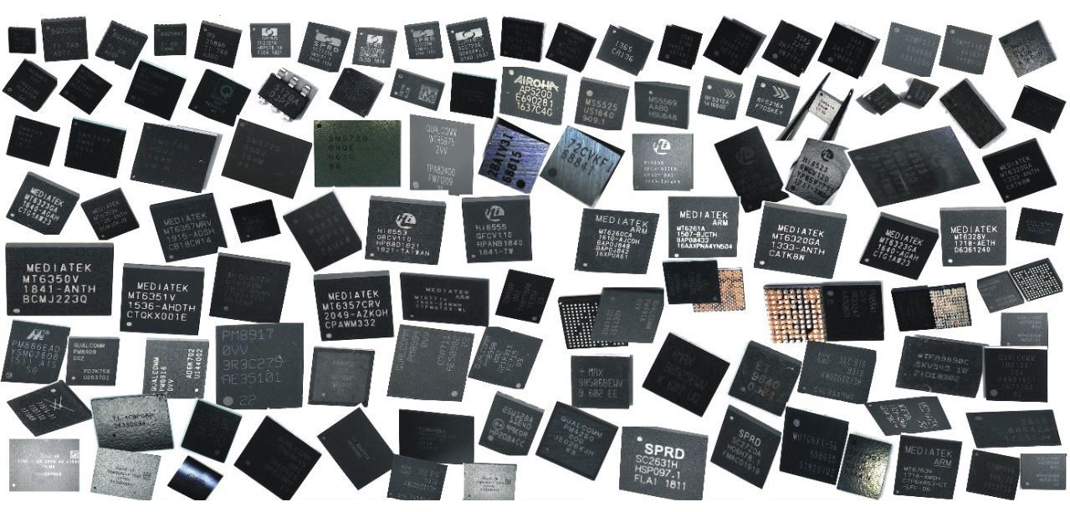

1. **MOBILE PHONE REPAIRING TOOLS**

mobile phone repairing tools, Screwdriver set, Precision screwdrivers, Tweezers, Spudger, Opening tool, Plastic prying tools, Suction cup, Heat gun, Soldering iron, Desoldering pump, Solder wire, Flux, PCB holder, Multimeter, ESD-safe wrist strap, Magnifying glass or microscope, Cleaning brush, Isopropyl alcohol, Thermal paste, Heat-resistant mat, Adhesive remover, UV curing lamp, Antistatic mat, Component organizer.

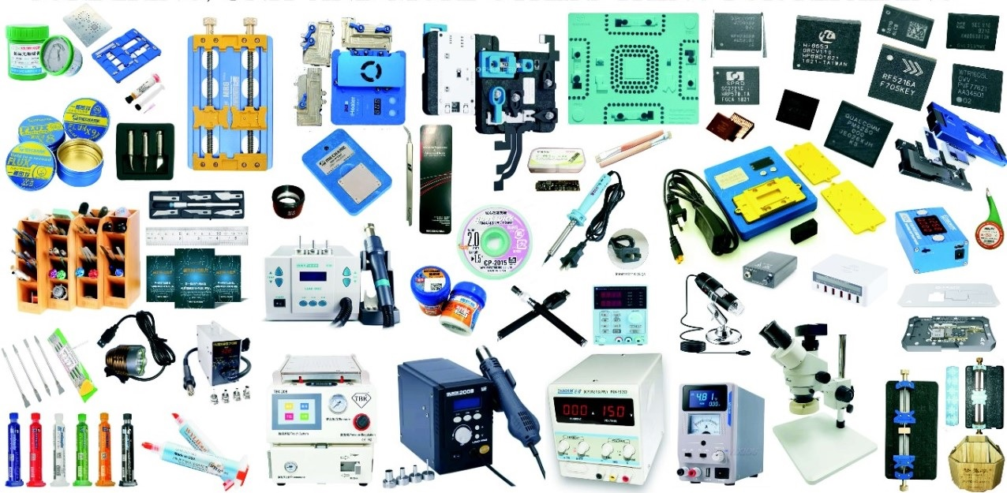

1. **MOBILE PHONE OCA GLASS REPLACEMENT**

* **FLATE GLASS REPLACEMENT**

mobile phone glass repairing, Glass replacement, Screen repair, Digitizer replacement, LCD repair, Cracked screen, Broken glass, Glass refurbishment, Touchscreen repair, Front glass replacement, Rear glass replacement, Screen protector installation, Adhesive application, Heat gun use, UV curing for adhesive, OCA (Optically Clear Adhesive) replacement, Glass polishing, Screen alignment, LCD calibration, Glass removal tool, Glass separator machine, UV lamp curing.

* **EDGE GLASS REPLACEMENT**

Mobile edge glass repairing, Edge glass repair, Curved glass repair, Mobile phone edge screen repair, Edge-to-edge glass repair, Bezel-less glass repair, Edge display repair, Mobile phone edge screen replacement, Edge screen refurbishment, Edge glass polishing, Edge glass adhesive, Edge glass alignment, Edge glass crack repair, Mobile phone edge screen refurbishment, Edge glass heat treatment, Edge glass UV curing, Edge glass inspection, Edge glass replacement guide, Mobile phone edge screen troubleshooting, Edge glass repair kit.

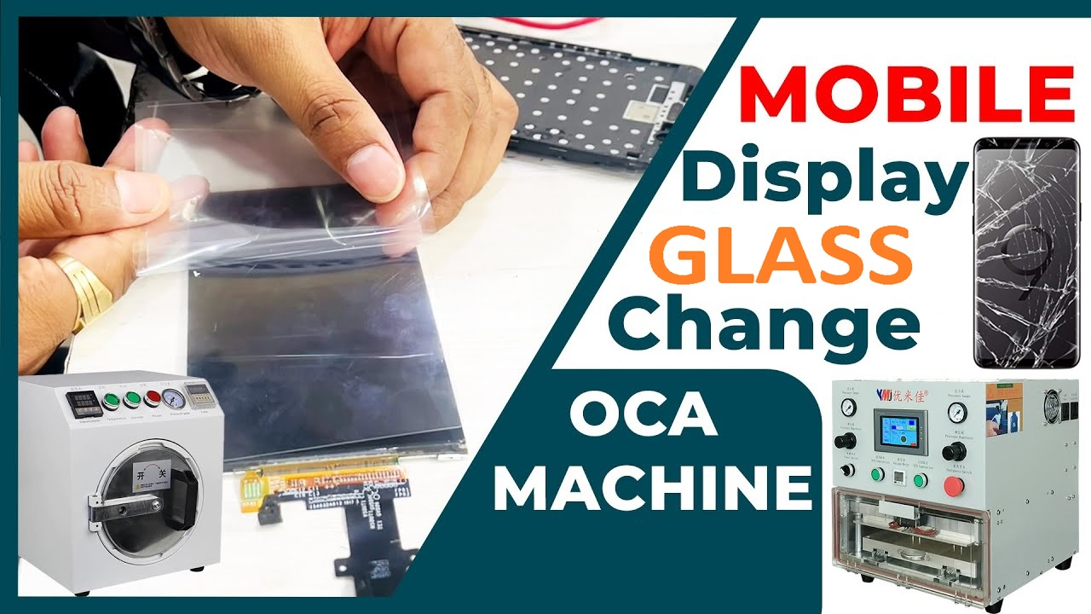

1. **MOBILE PHONE LCD FLEX REBON REPLACEMENT**

* **FLATE LCD FLEX REPLACEMENT**

mobile phone LCD flex changing, Flex cable replacement, LCD flex ribbon, Flex connector, Ribbon cable, Flex cable assembly, LCD flex repair, Flex cable damage, Flex cable removal, Flex cable installation, Flex cable connector, LCD flex troubleshooting, Flex cable compatibility, Flex cable soldering, Flex cable adhesive, Ribbon cable repair, Flex cable testing, Flex cable alignment, LCD flex replacement guide, Flex cable heat treatment, Flex cable insulation, Flex cable insulation tape, Flex cable insulation sleeve, Flex cable pinout diagram.

* **EDGE LCD FLEX REPLACEMENT**

Mobile phone edge LCD flex changing, Edge screen repair, Curved screen repair, Edge-to-edge display repair, Mobile phone edge LCD flex replacement, Edge LCD flex cable replacement, Edge screen flex cable repair, Edge screen digitizer flex replacement, Edge screen ribbon cable replacement, Edge display flex cable installation, Edge LCD flex troubleshooting, Edge screen flex cable compatibility, Edge screen flex cable soldering, Edge screen flex cable adhesive, Edge LCD flex cable alignment, Edge LCD flex cable removal, Edge screen flex cable heat treatment, Edge screen flex cable insulation, Edge screen flex cable insulation tape, Edge screen flex cable insulation sleeve, Edge LCD flex cable pinout diagram, Edge screen flex cable repair guide, Mobile phone edge LCD flex changing equipment, Edge LCD flex cable repair kit.

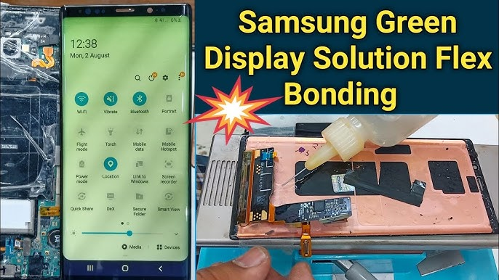

1. **MOBILE PHONE OCA GLASS MACHINE AND TOOLS**

mobile phone OCA glass repairing machine, OCA laminating machine, Glass laminating machine, OCA film laminator, Vacuum laminating machine, LCD laminating machine, Bubble remover machine, Automatic OCA laminator, Manual OCA laminator, LCD separator machine, OCA film remover machine, Bubble remover machine, Touch screen separator machine, LCD glue remover machine, OCA glue remover machine, LCD glass refurbishing machine, OCA alignment machine, Polarizer remover machine, LCD repair machine, Touch screen repair machine, LCD refurbishment machine, Mobile phone repair equipment, Mobile phone refurbishing tools, LCD laminating bubble remover, OCA laminating machine accessories.

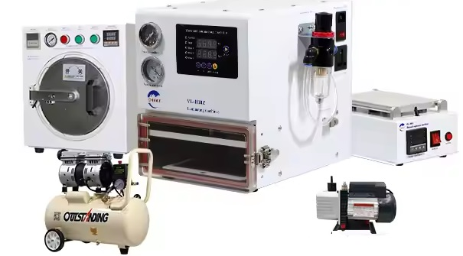

1. **MOBILE PHONE CHARGING PORT**

Mobile phone charging port, Charging port repair, Charging port replacement, Micro USB port, USB-C port, Lightning port, Charging port connector, Charging port flex cable, Charging port assembly, Charging port soldering, Charging port damage, Charging port cleaning, Charging port repair tools, Charging port flex cable replacement, Charging port water damage, Charging port dust cover, Charging port flex cable repair, Charging port pins, Charging port inspection, Charging port alignment, Charging port testing, Charging port soldering iron, Charging port adhesive.

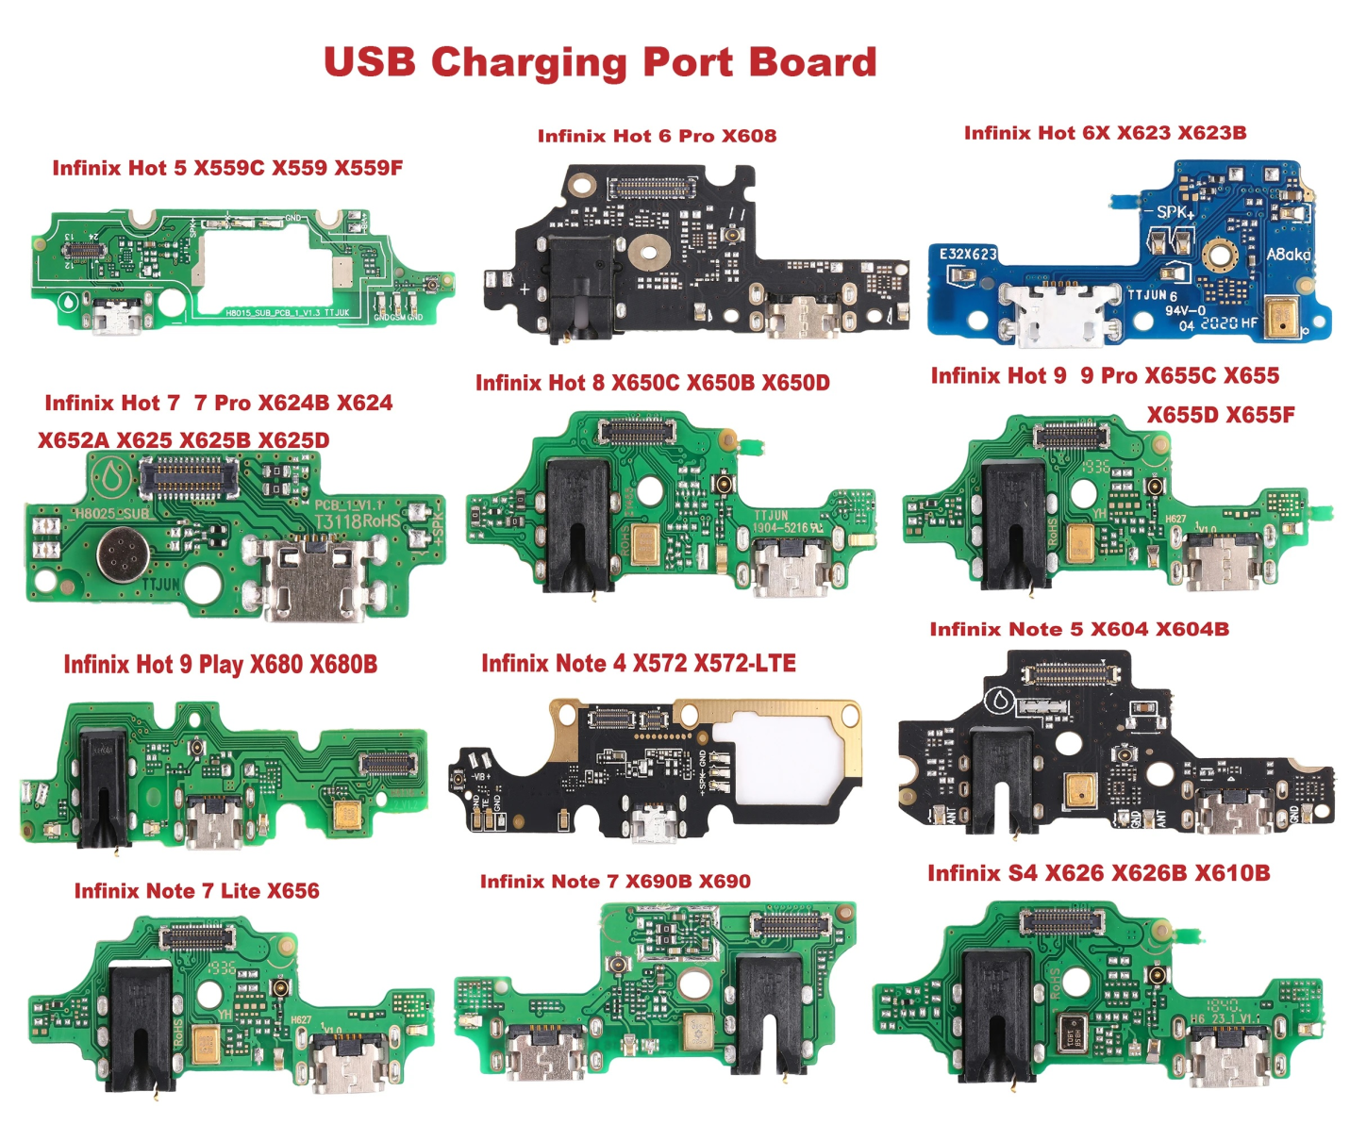

1. **MOBILE PHONE BACK AND FRONT CAMERA OEM**

Mobile phone back and front camera, Rear camera, Front camera, Dual camera, Camera module, Camera lens, Image sensor, Megapixels, Autofocus, Optical image stabilization (OIS), Electronic image stabilization (EIS), Aperture size, Wide-angle lens, Telephoto lens, Portrait mode, Night mode, HDR (High Dynamic Range), Panorama mode, Slow-motion video, Time-lapse video, Camera flash, Selfie camera, Depth sensor, Camera shutter, Camera app.

